Terraform challenge

Write a code using Terraform that deploys and achieves the following:-
- Create an EC2 Instance on AWS Cloud using the below-mentioned ubuntu AMI and instance_type. Or, (You can use of your choice as well) ami = "ami-0461b1436c9b3c1a3" instance_type = "t2.micro"
Create a folder and open it and created main.tf file, versions.tf
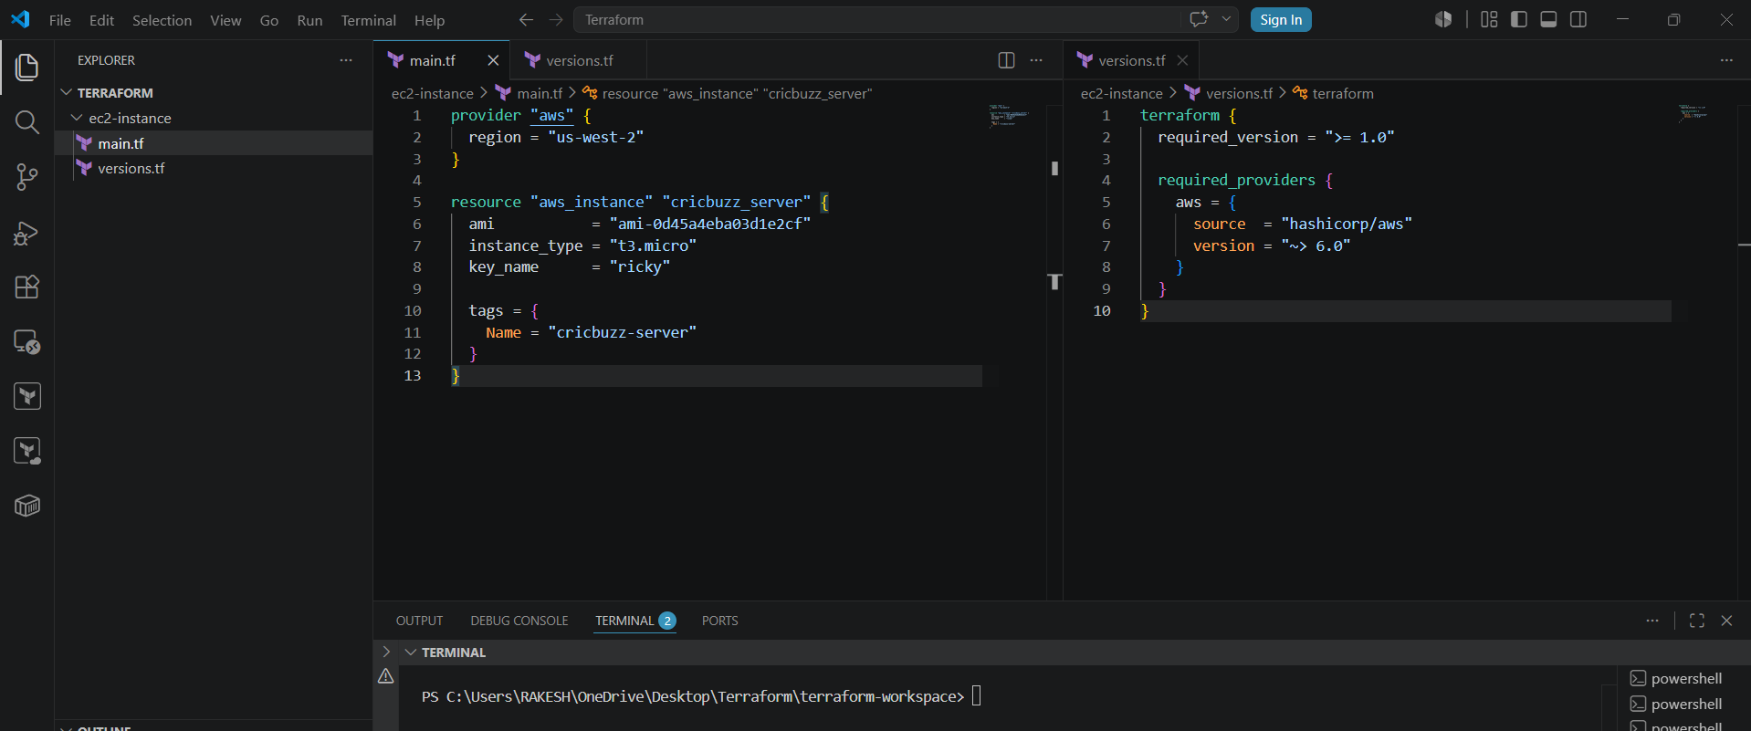
Now do Terraform init, fmt, validate, plan and apply
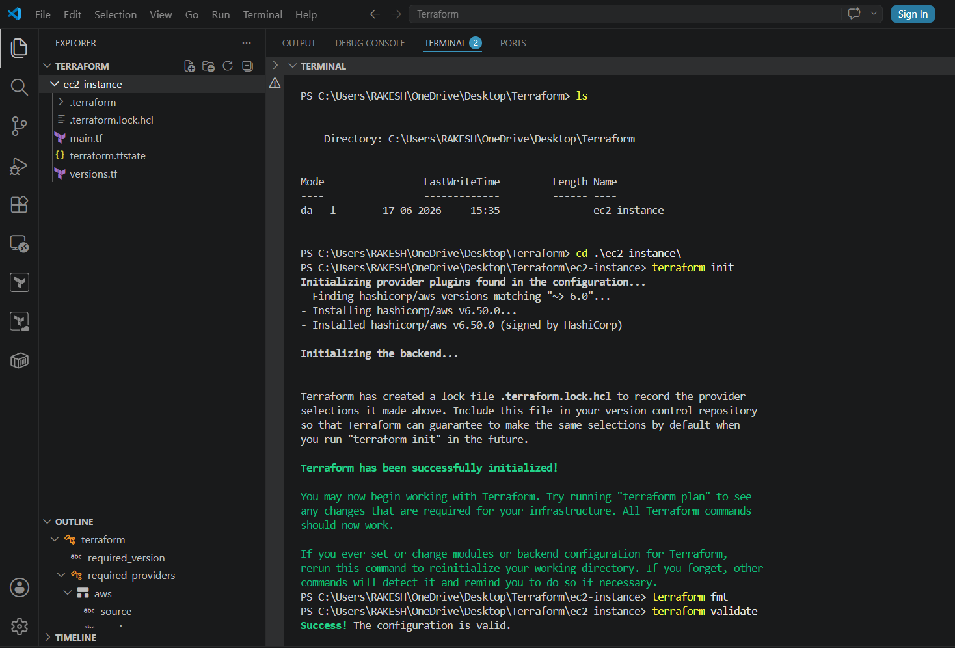
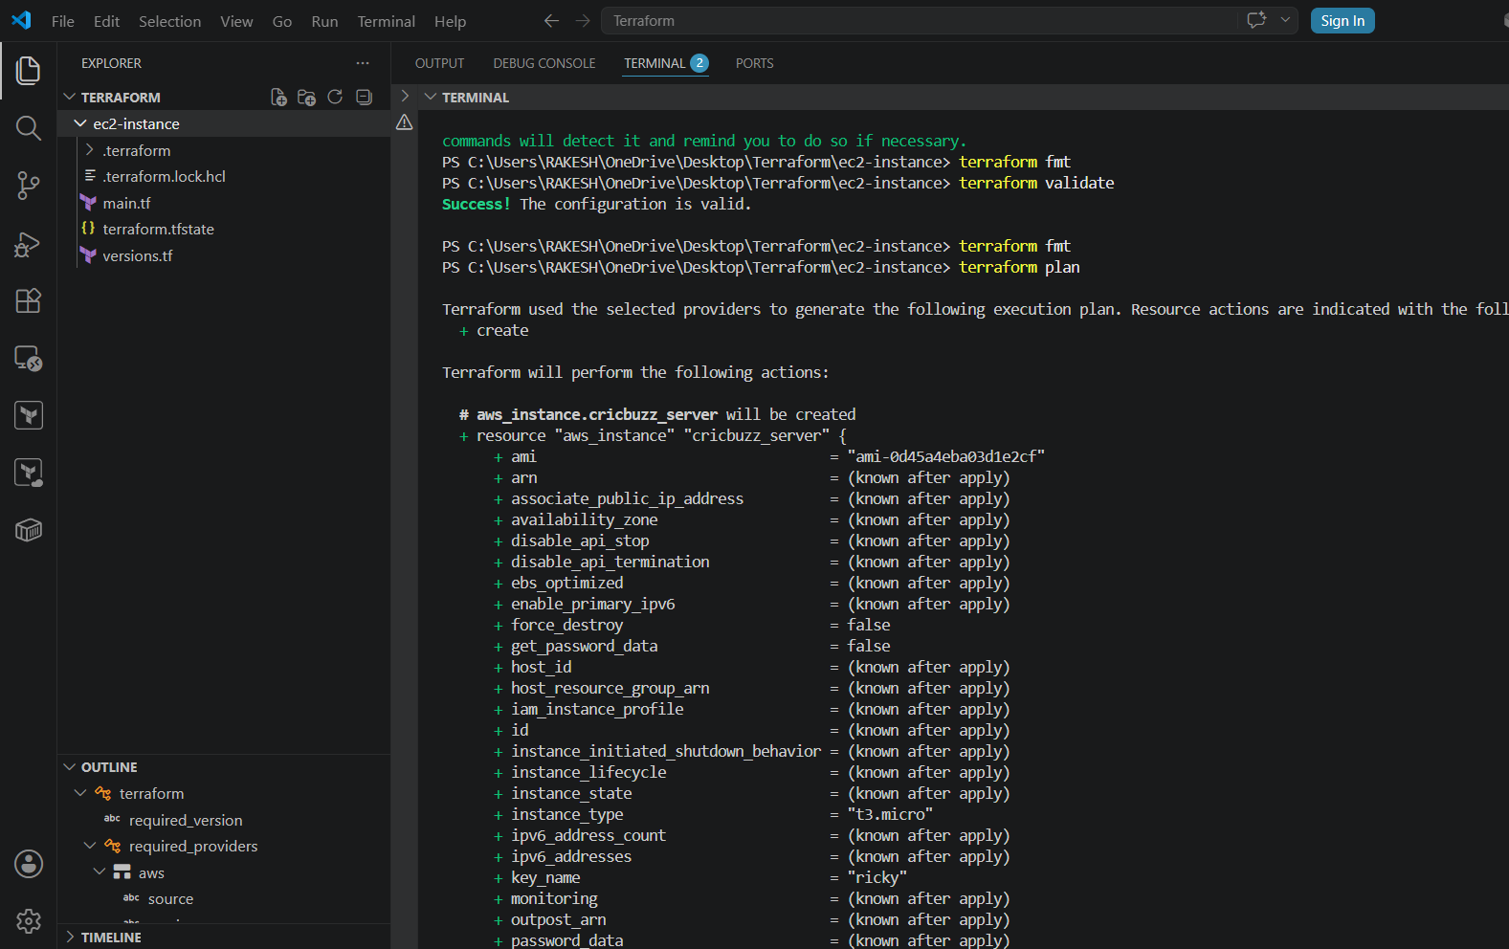
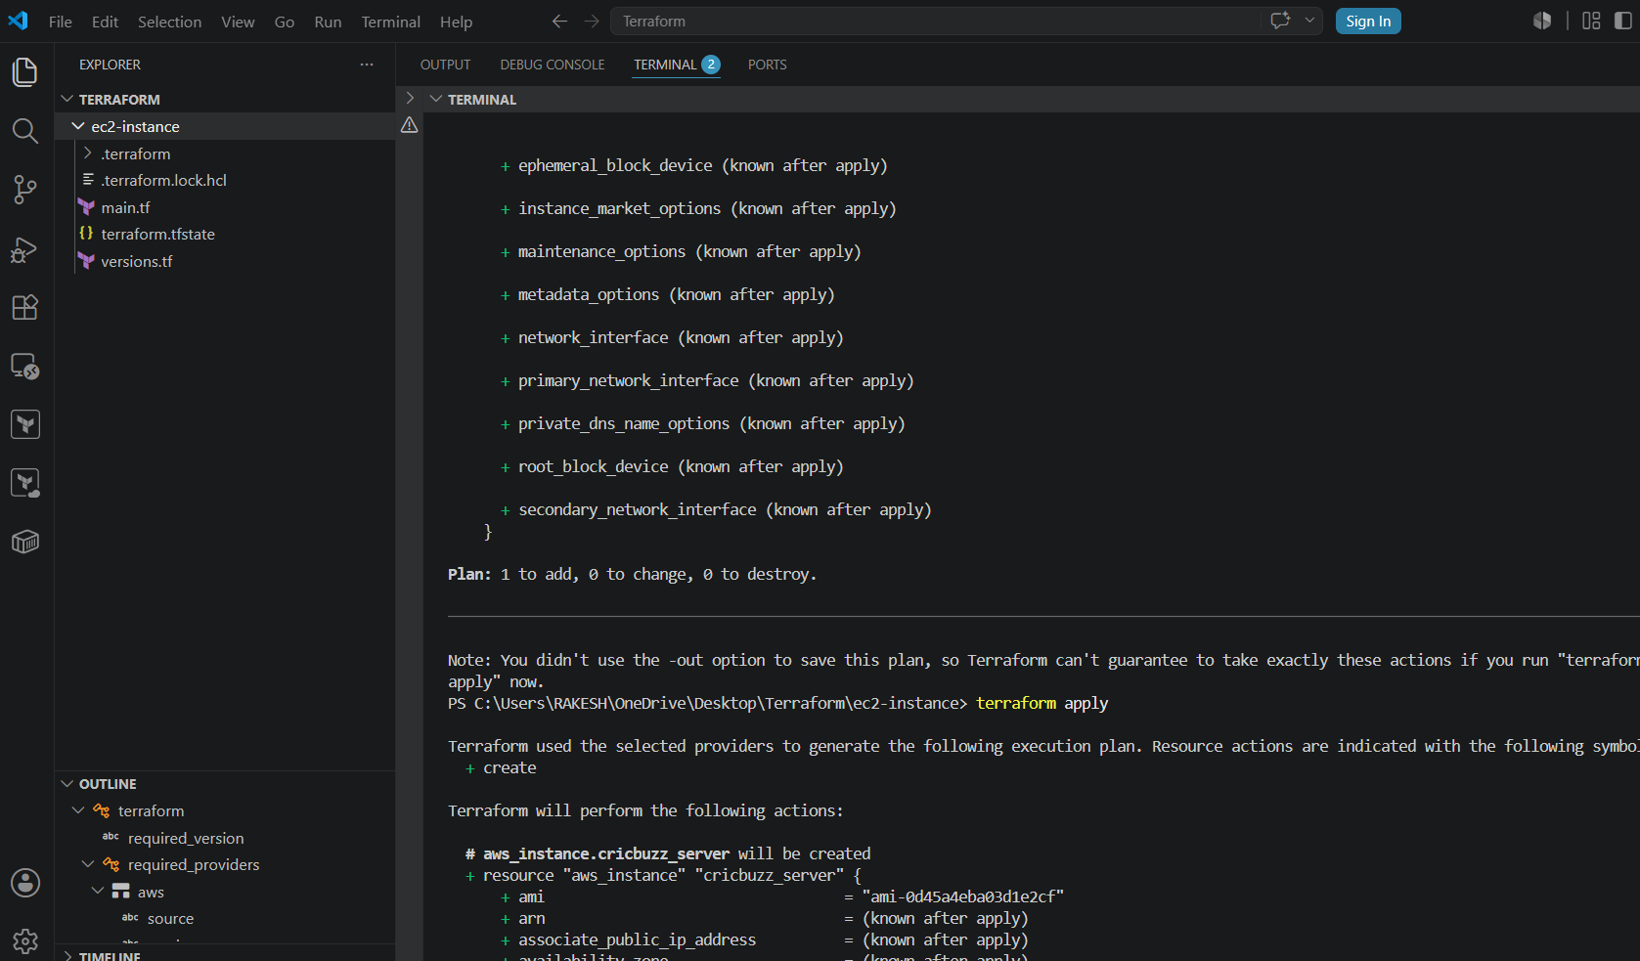

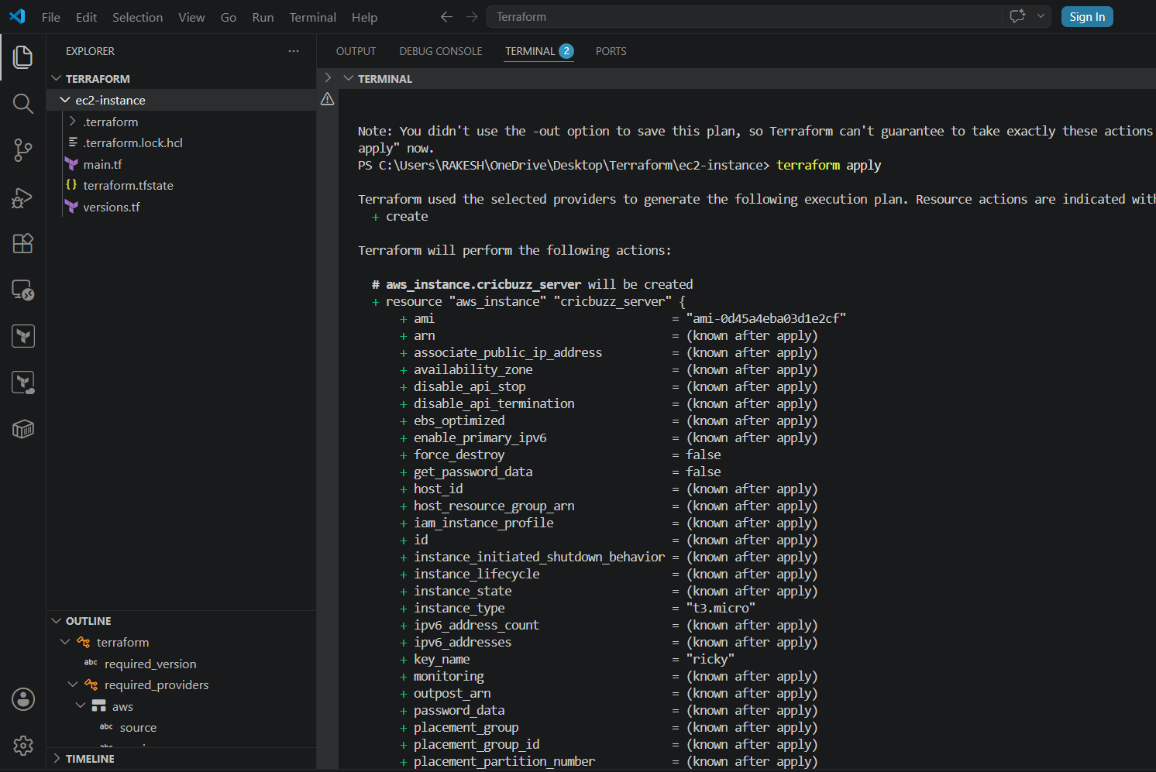
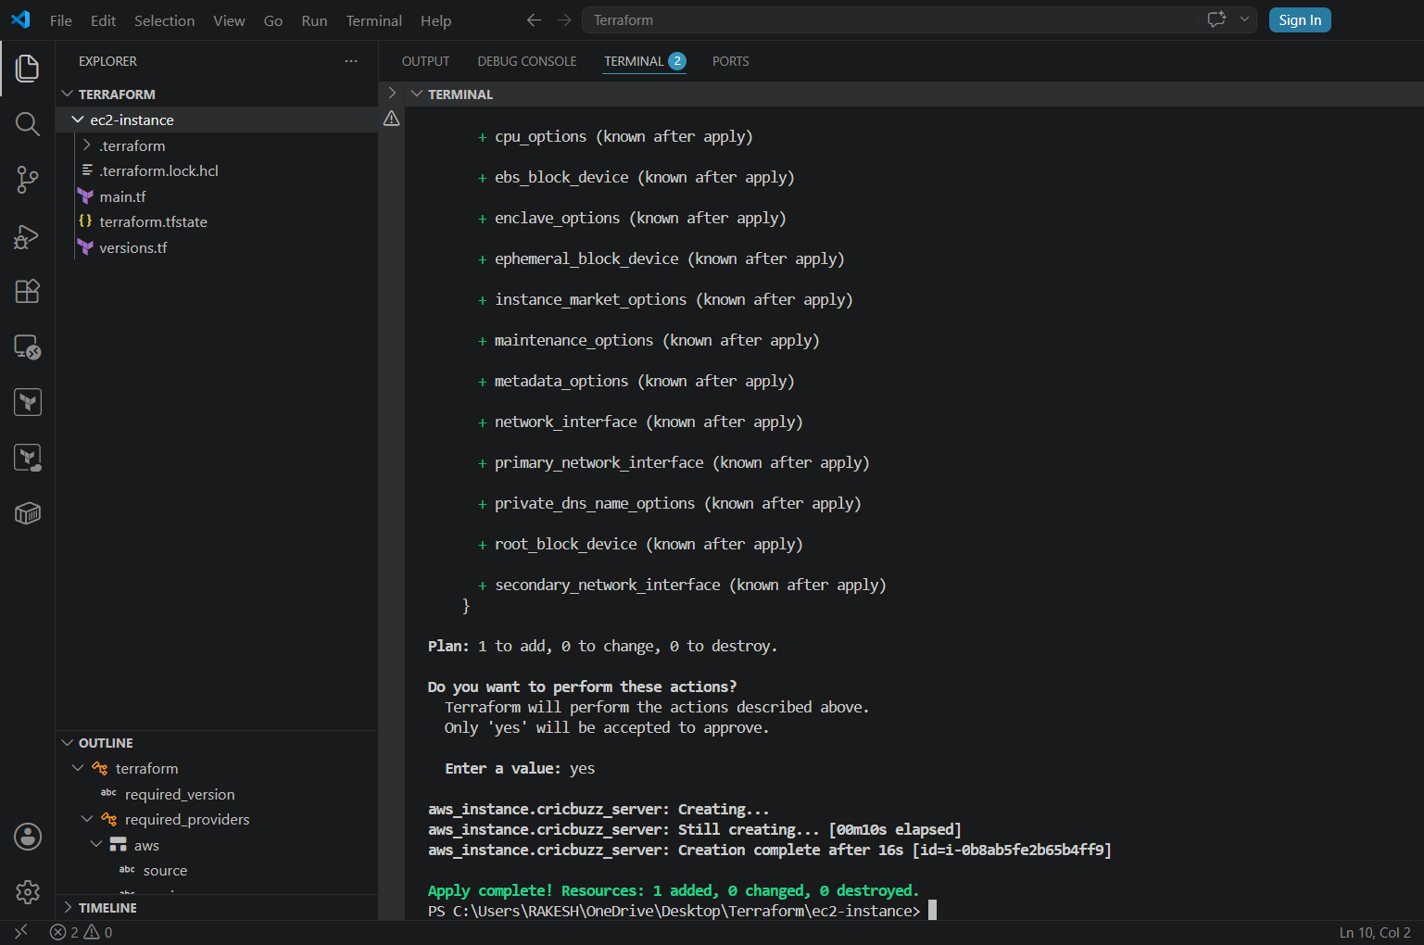
Now we can see ec2 instance has been created
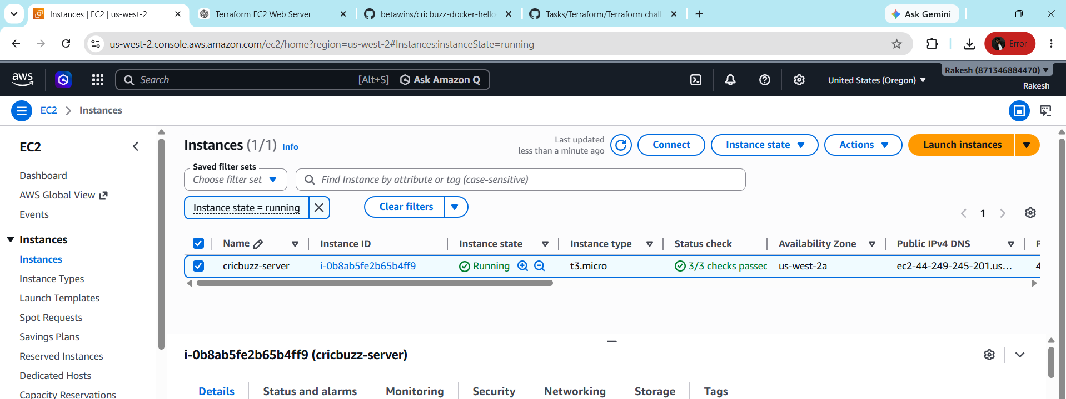

- Install a web server on the same EC2 Instance. The web server should listen on port 8080.
• main.tf file created
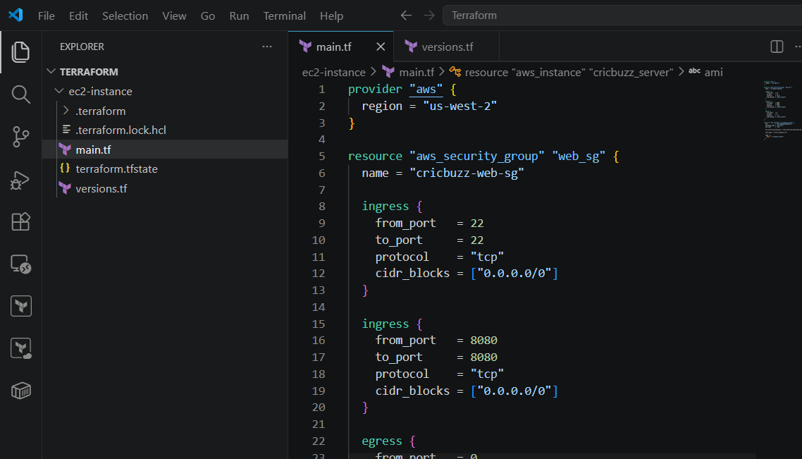
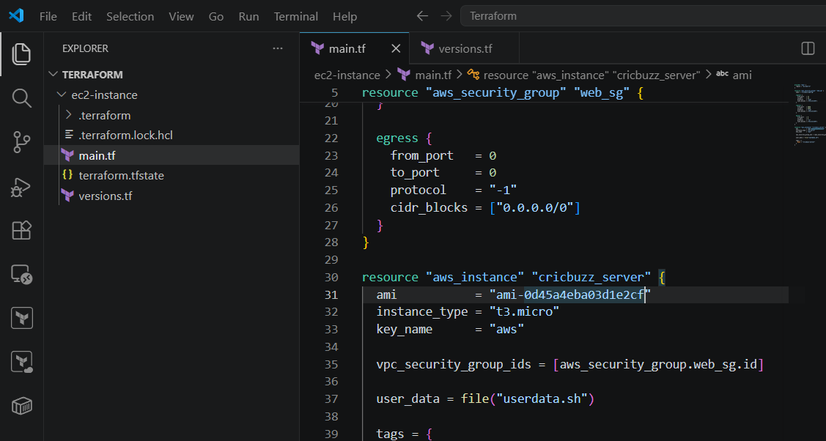
• Userdata.sh file created
dnf update -y
dnf install nginx -y

cat > /usr/share/nginx/html/index.html <<HTML
<h1>Nginx Running on Port 8080</h1>
HTML

cat > /etc/nginx/conf.d/web.conf <<NGINX
server {
listen 8080;
server_name _;
root /usr/share/nginx/html;
index index.html;
}
NGINX

systemctl enable nginx
systemctl restart nginx
EOF
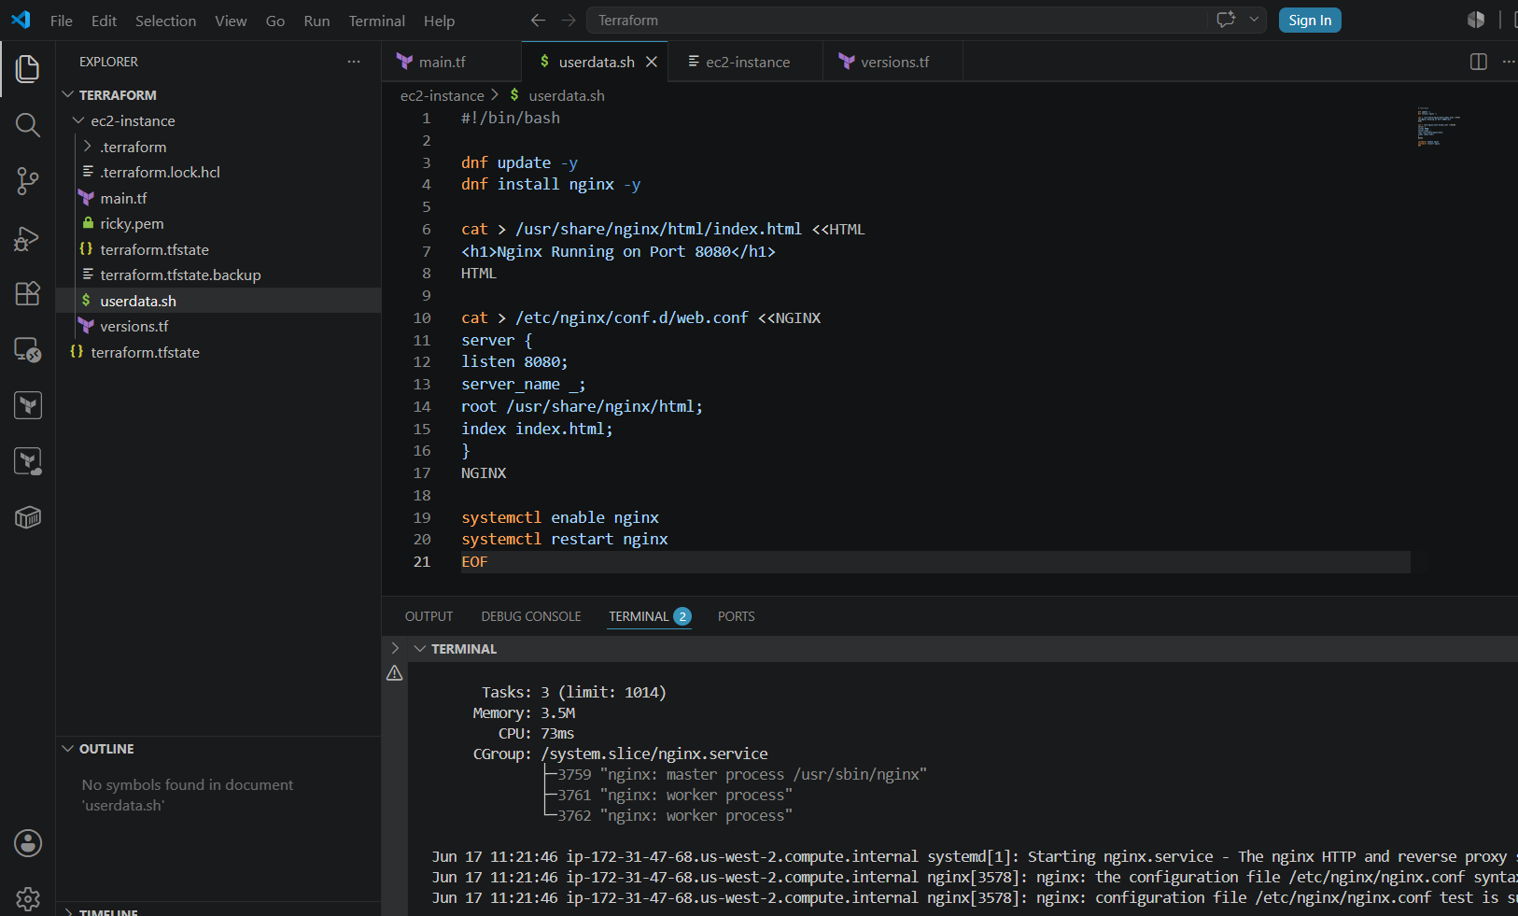

• New do Terraform init, plan and apply
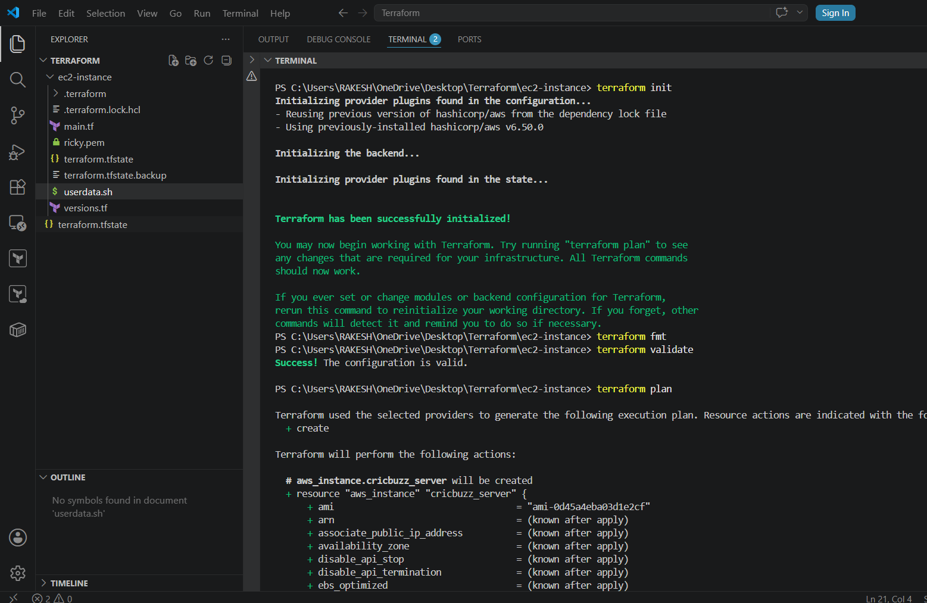
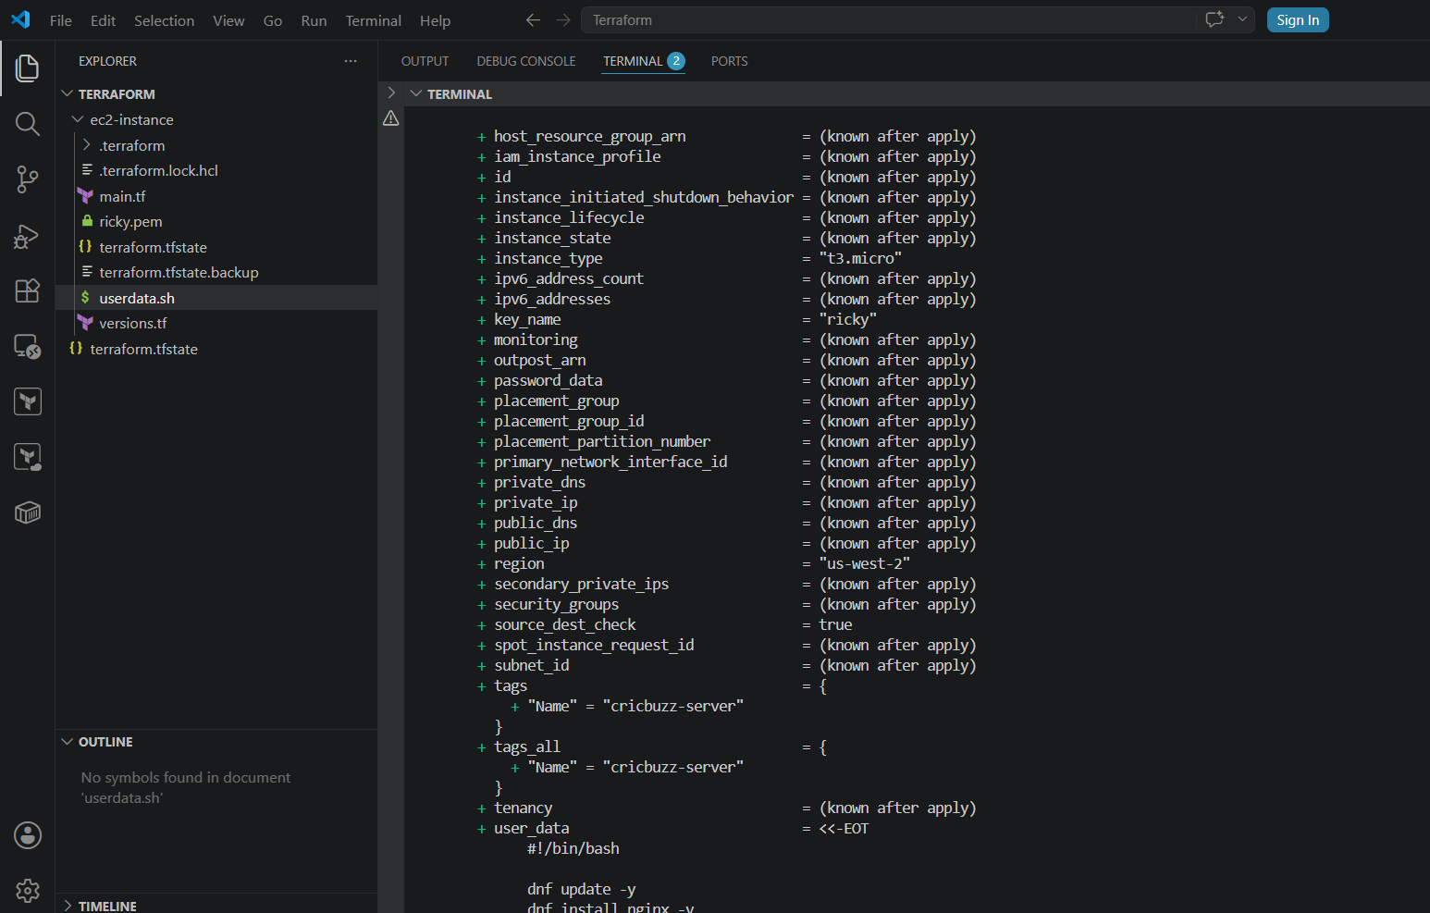
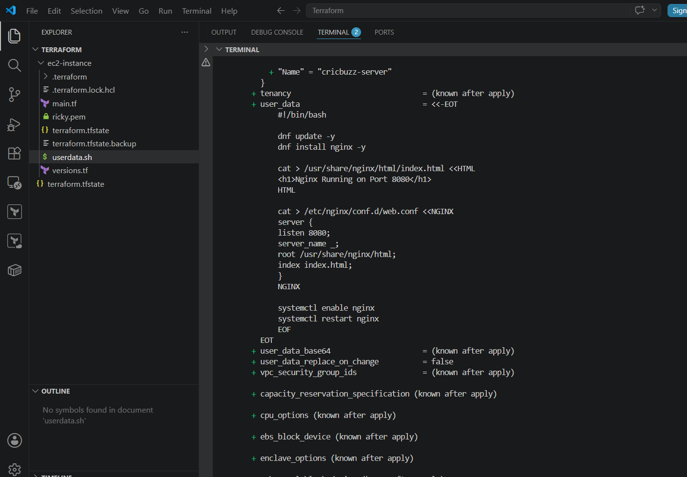

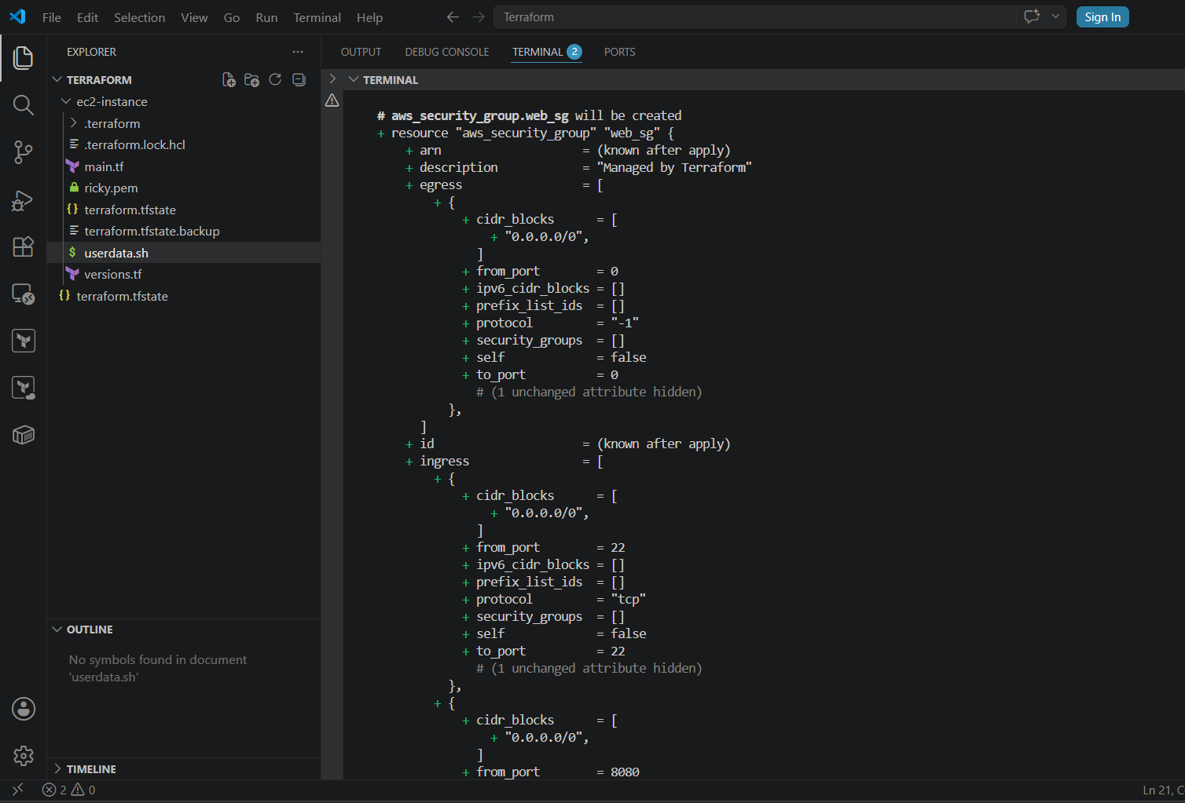

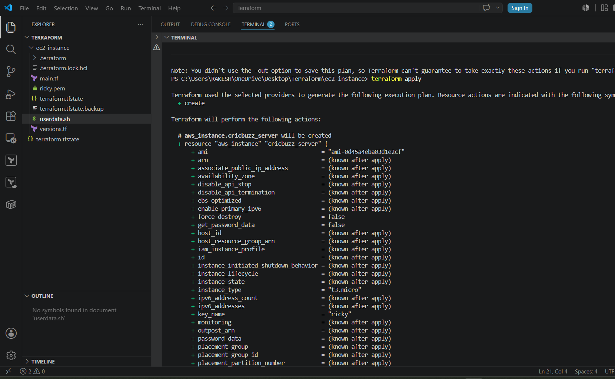

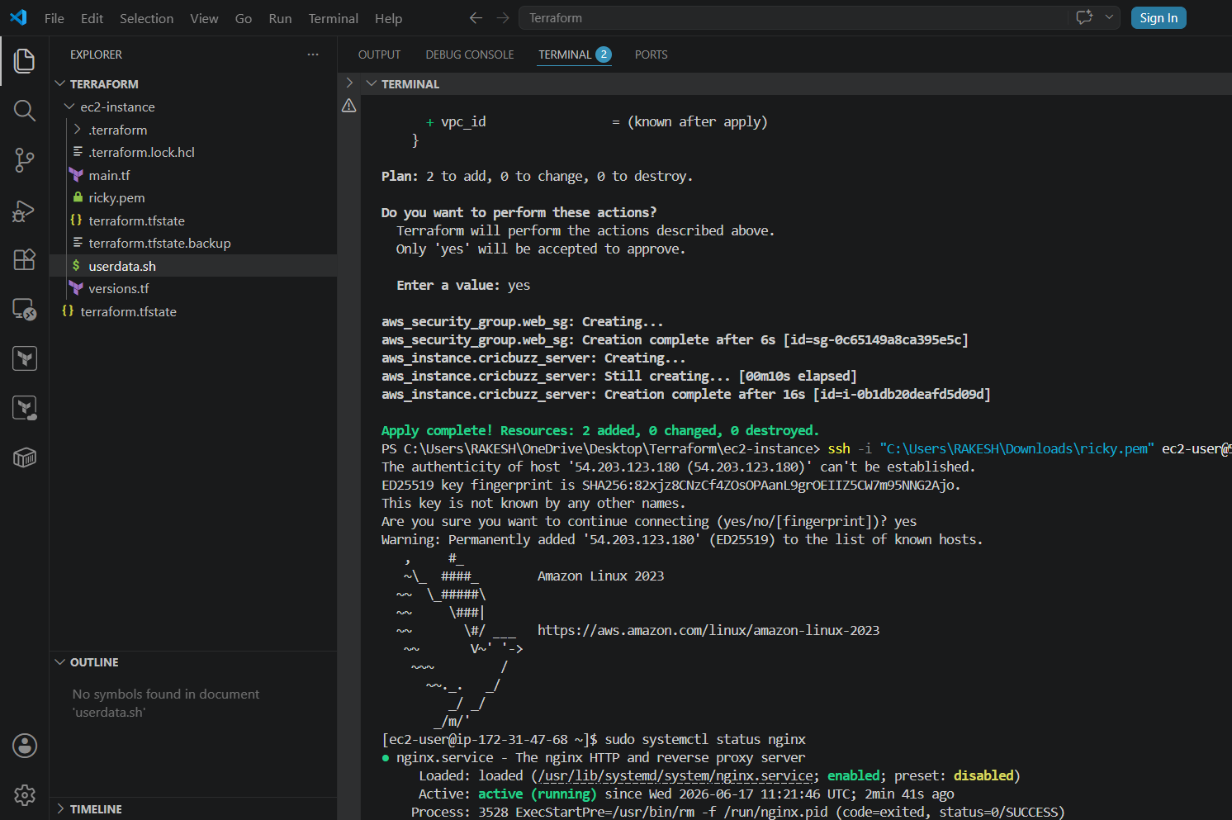

• Check AWS EC2 instance created
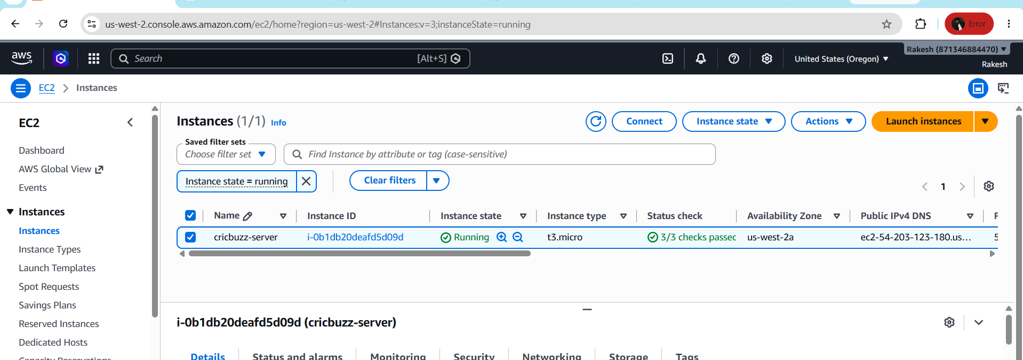

• Connect with SSH to EC2 and check status of Nginx
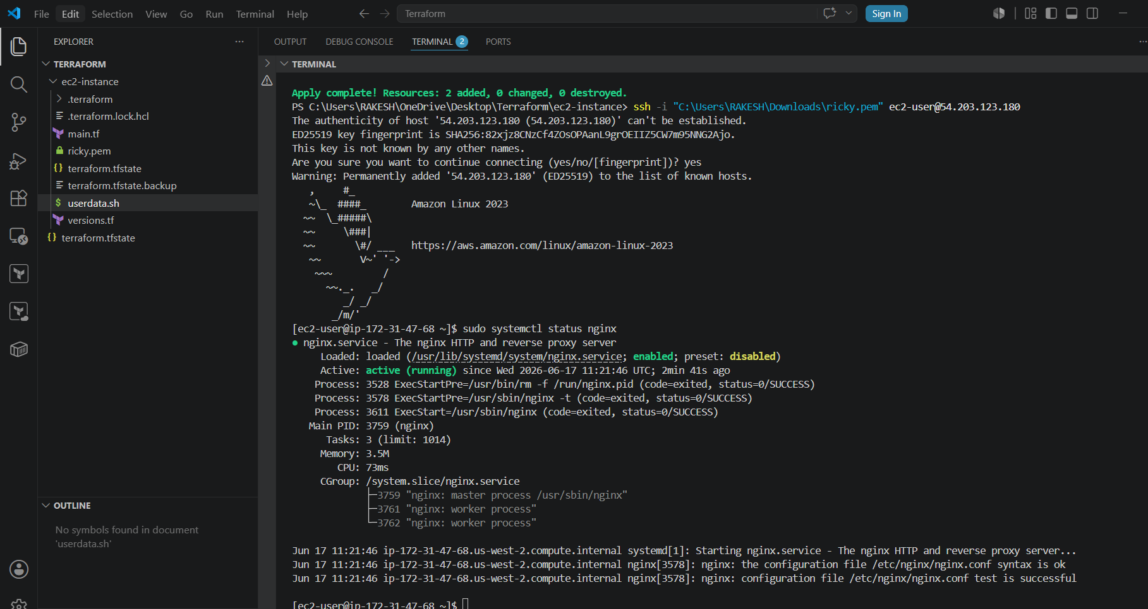
• Now check Response
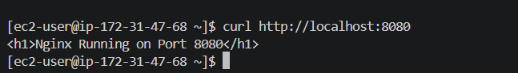
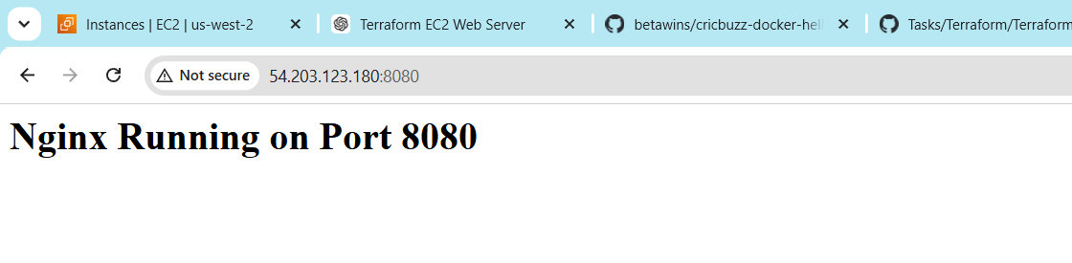

- Create a Docker-compose file for the project:https://github.com/betawins/cricbuzz-docker-hello-world.gitand point it to port 8000.
- Make the web server point to the above service so that 8080 returns the response from the Docker service.
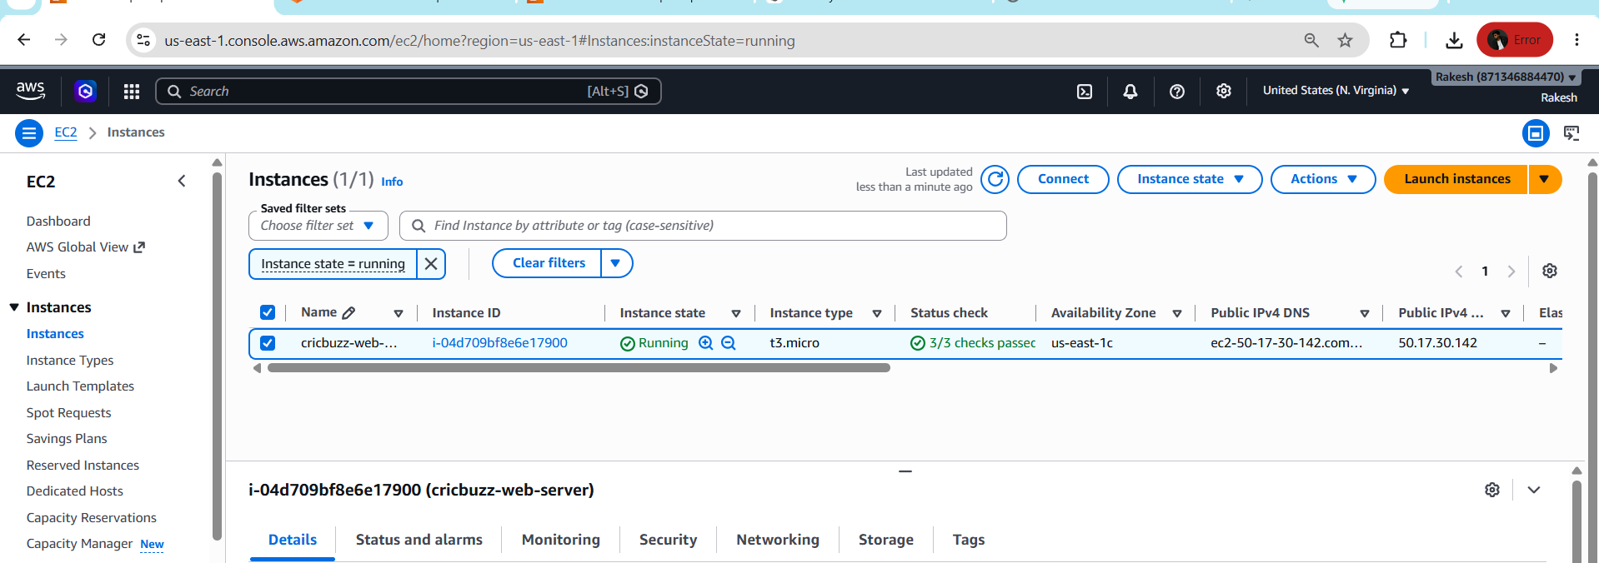
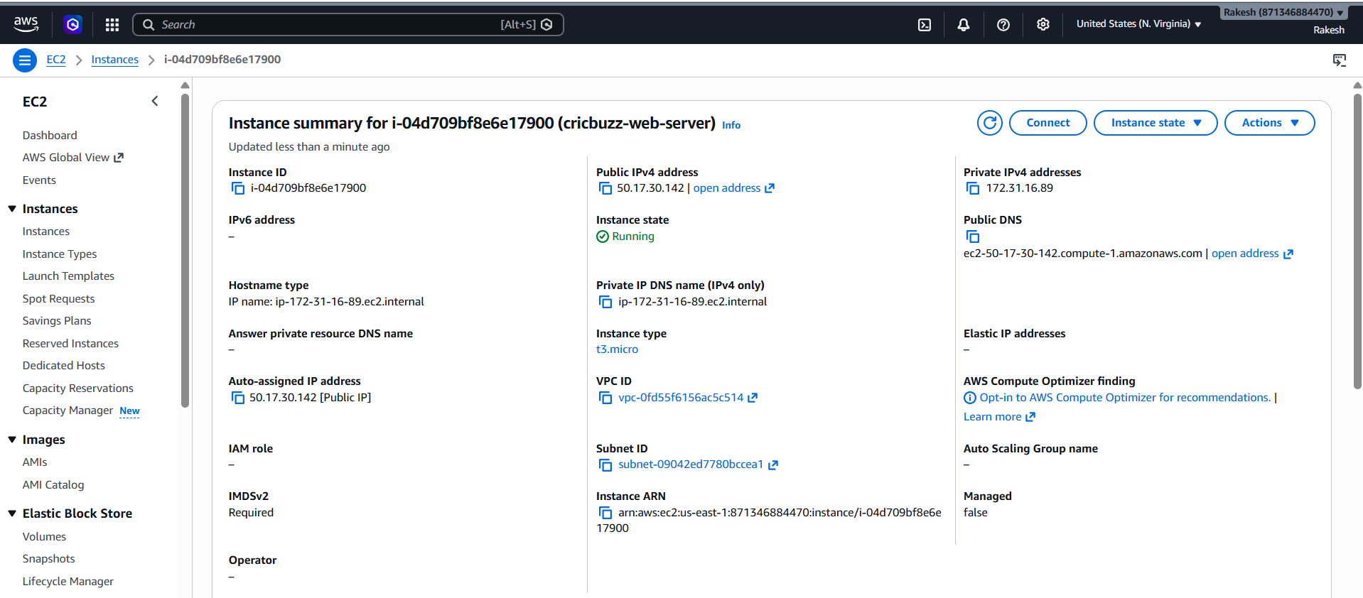
This is the script for main.tf file
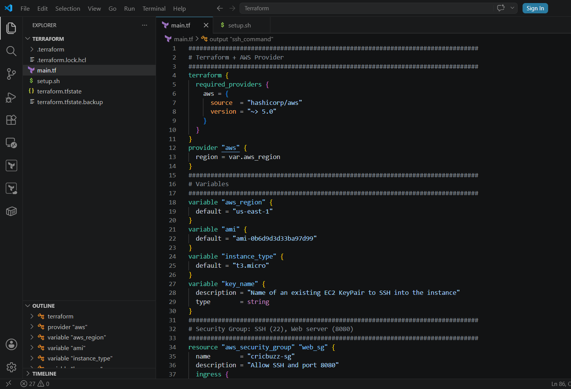
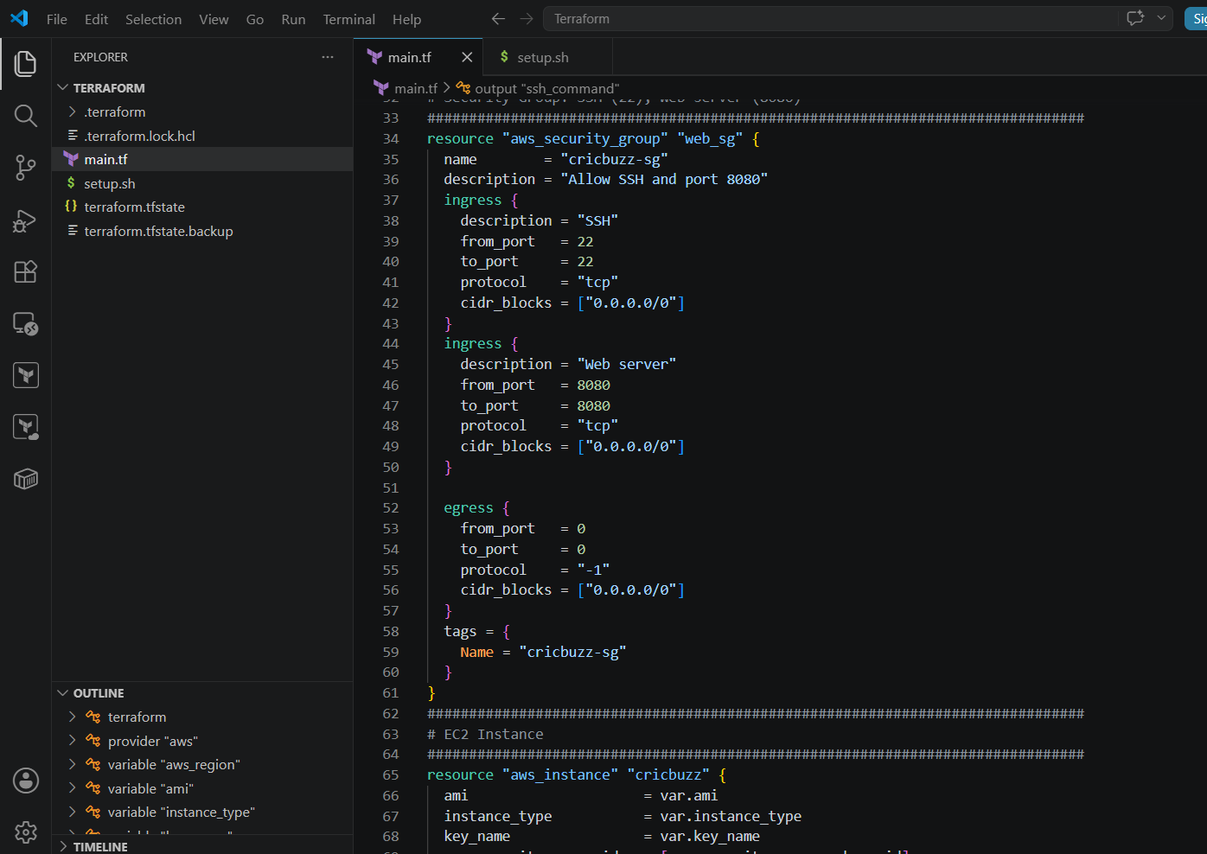
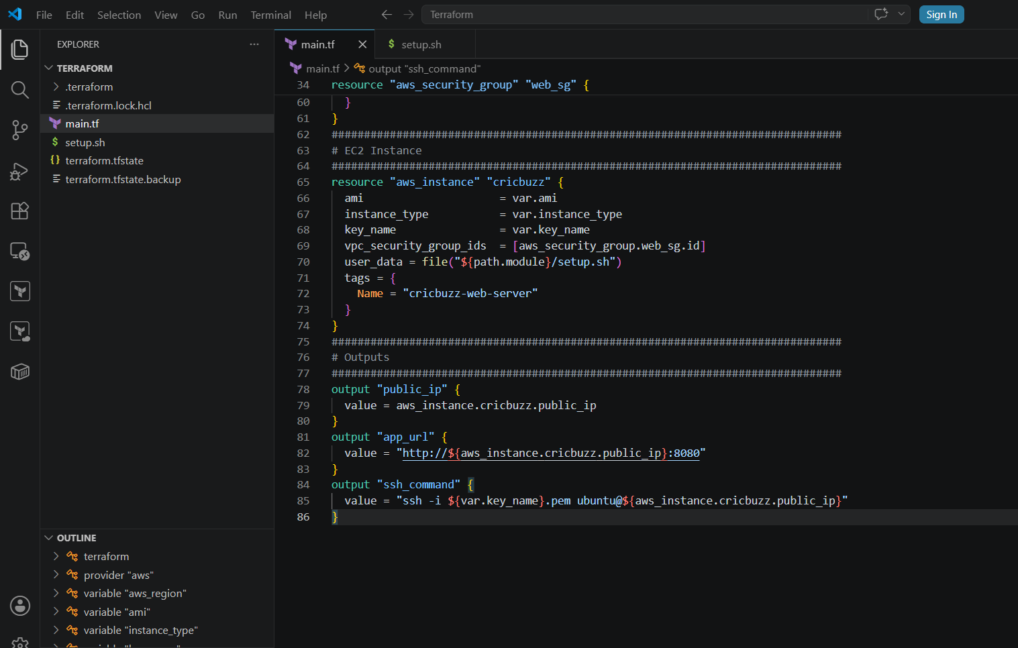
This is the script for setup.sh file
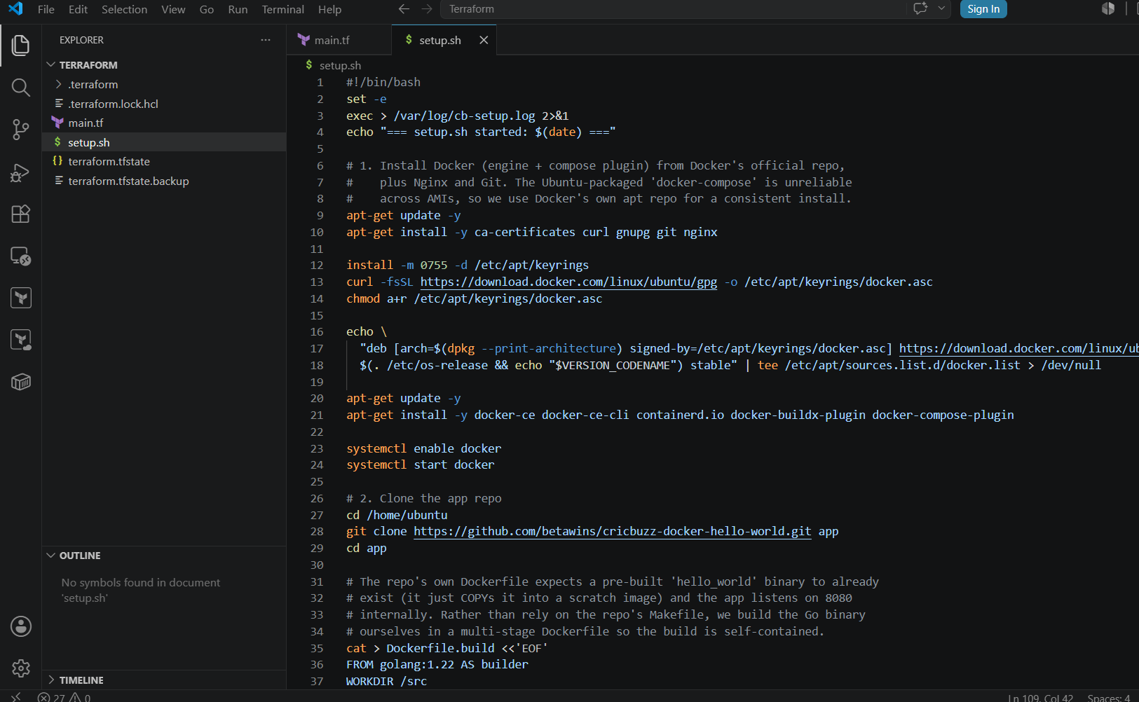

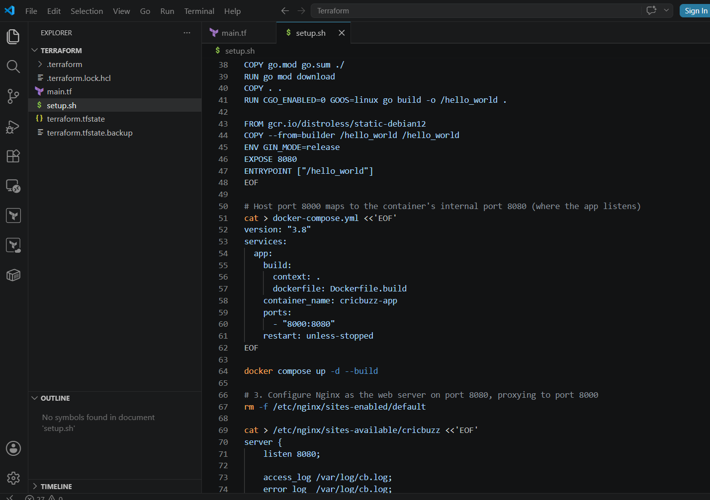
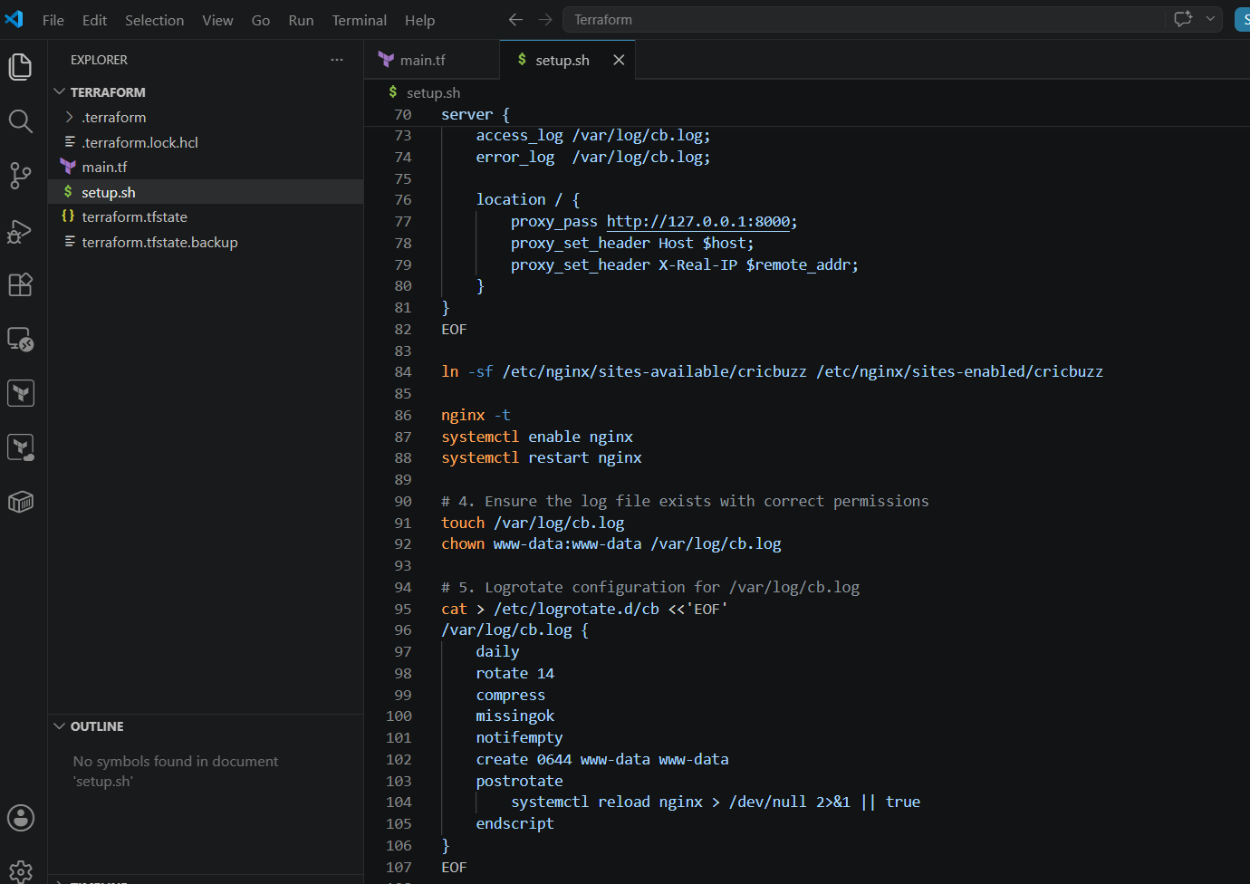
terraform init
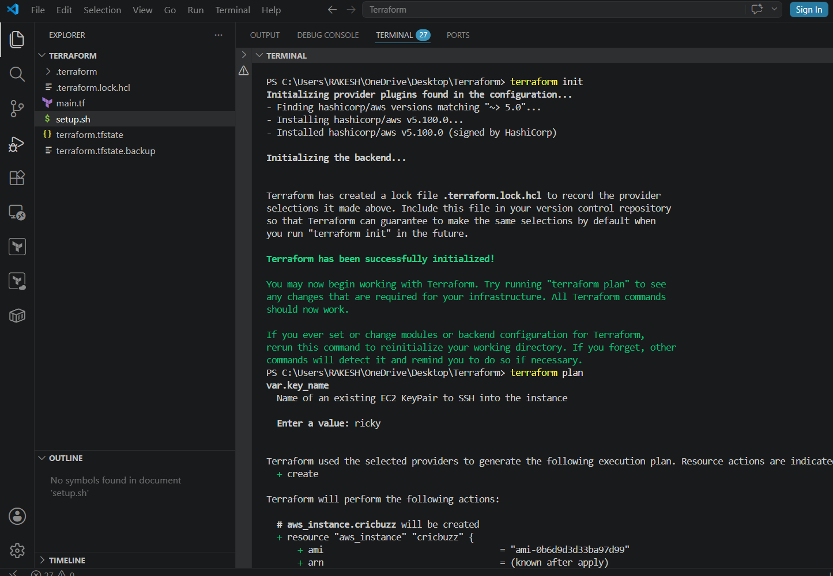

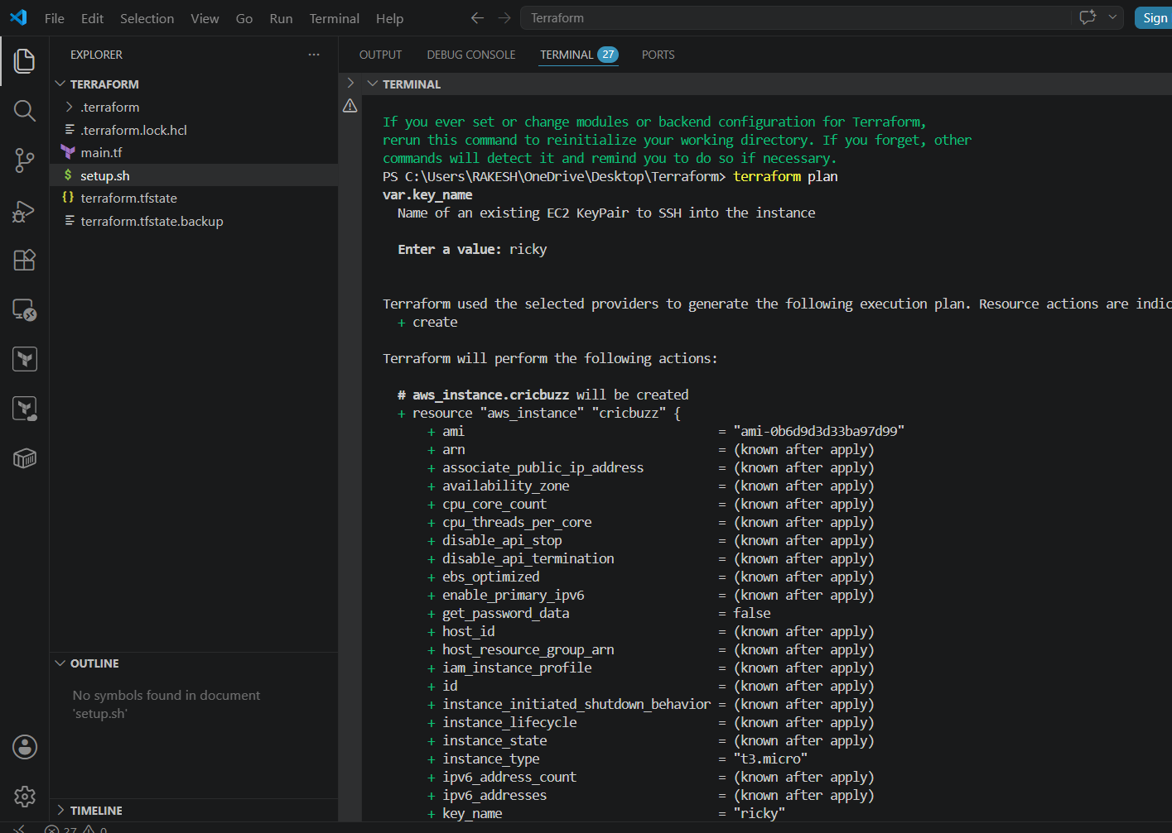
terraform apply
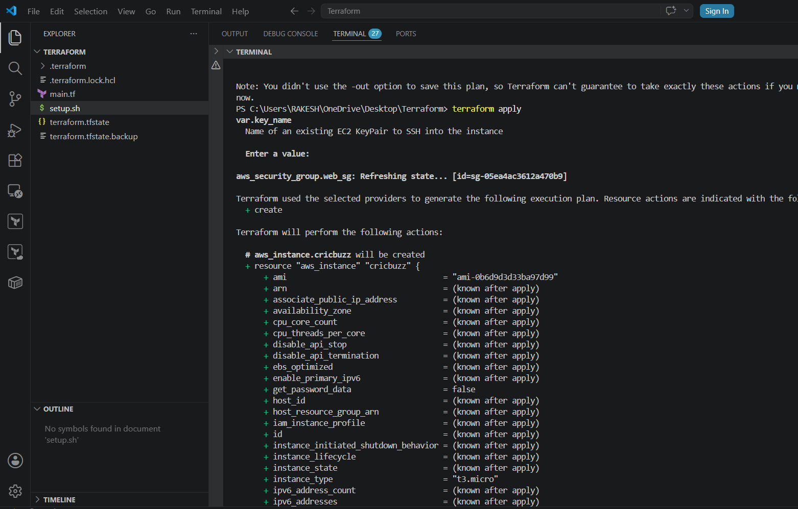
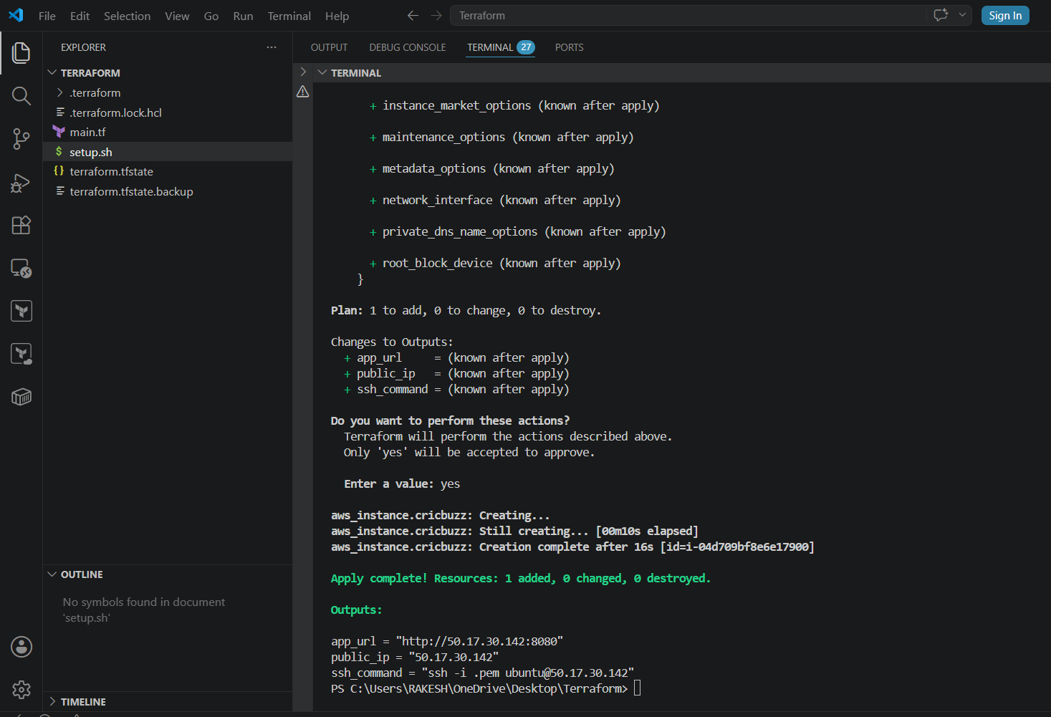
app_url = "http://50.17.30.142:8080"
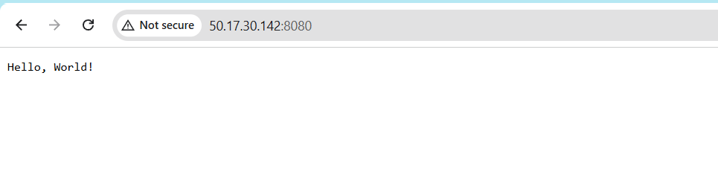

- Configure to Save the Logs in the location /var/log/cb.log
- Write the Log rotate configuration for the above file
We are able to see the logs
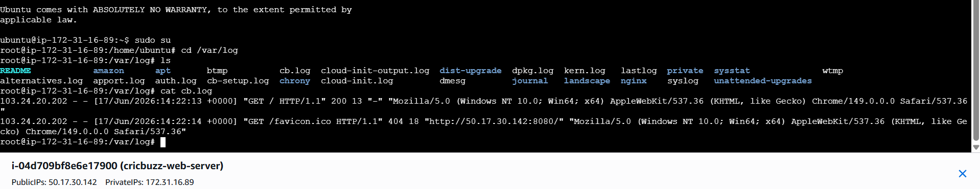
Log rotate output
